

Pages of Parkview

November – December 2024



Key Personnel within the Organisation.

General Manager Michael Powell
Care Manager Diane Newham
Office Coordinator Sarah Clayton
Human Resources Leanne Walker
Lifestyle Supervisor Amanda Weger
Catering Supervisor Susan Bensen
Maintenance Supervisor Paul Tomlinson
Environmental Supervisor Jane Delaney


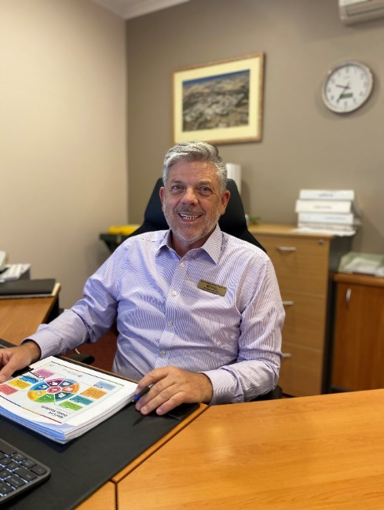
Dear Residents of Parkview
Michael is currently on leave and will be returning later in November.
On behalf of Parkview Nursing home,
we would like to update you all on our Laundry renovations. As some of you may know we have been preparing for our laundry to be fully refurbished. A temporary laundry has been set up and is now ready to go. We are excited to announce the official start is November 6th. The contractors will start by setting up their amentities and fencing and then get started on removing the contents of the current laundry and then refurbishing the new fittings and equipment. The contractors will minimise the noise and dust as much as possible. We would like to reassure you that this disruption is expected to be short term. The washing will continue to be washed, dried and returned to your family member as usual. Please let us know if there are any concerns raised during this time so we can address them as soon as possible.

We are delighted to announce that Dianne Newham has been appointed to the role of Parkview Care Manager effective 22nd October. Please congratulate Di on her appointment, she was an outstanding candidate and we know she will be an outstanding Care Manager with us.

On behalf of Management and Staff we wish you all a “Merry Christmas and a prosperous New Year for 2025”

Kind regards,
Amanda Weger
Lifestyle Supervisor

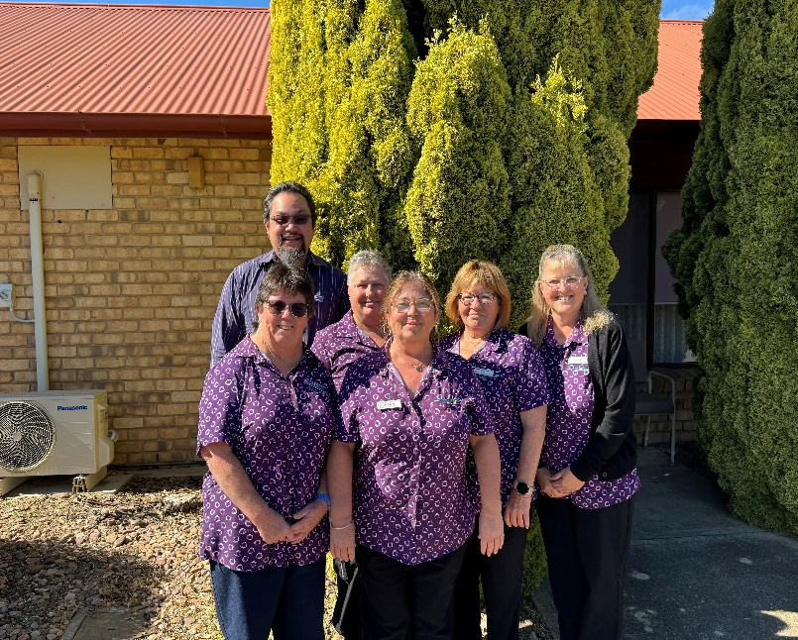
Hi all,
Our silly season has arrived!! What a fantastic year we have had in the Lifestyle Department. Every month the Lifestyle team come up with new activities and events to keep our residents active and connecting to our community. Highlights have been, our Sun of Africa Drummer who entertained us with his techniques as well as teaching our residents how to play the drums. We have been visiting our local library, the Vietnam Vet centre, Probus, Moonta Kindergarten, various Hotels, Garden centres, parks, beaches and Fashion Parades. Ours residents have been very busy and enjoyed our events this year!
During November we will be having Melbourne Cup, with our ladies parading on the catwalk their fascinators and hats. We will be honouring Remembrance Day and we have our resident, Margaret Ashton, who will be having her head shaved and has raised money for her efforts for the Leukaemia Foundation.
Lifestyle team are preparing for our Residents Christmas Luncheons and invitations will be coming to families really soon. We will be decorating the facility once again and have purchased some new decorations.
On behalf of Parkview Aged Care, I would like to say a BIG THANK YOU to our Volunteers, Carol, Jan, Margaret, Liz, Katherine, Russell, Sandra and Sharon we are so ever grateful for giving us your time and assisting our residents when needed.
Our next “Pages of Parkview” will be in January, until then I wish you well and keep safe and have a Merry Christmas and a Happy New Year.
That’s all from me for now, until next time.
Amanda Weger
Senior Lifestyle Coordinator

Lifestyle Activities:

Fathers Day:
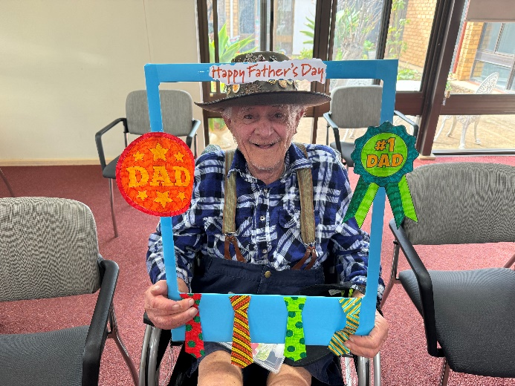
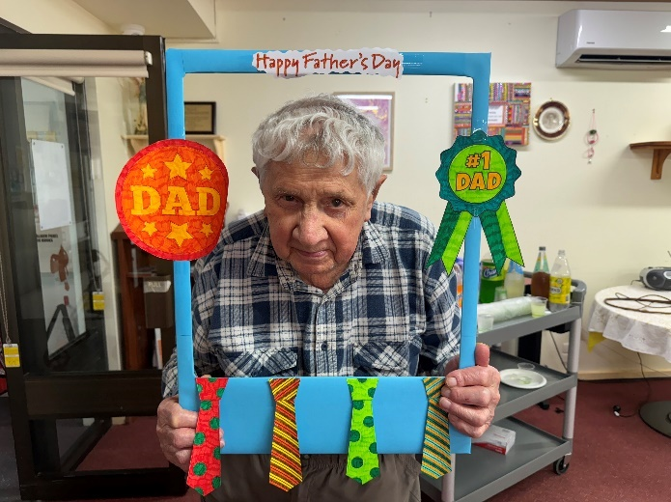

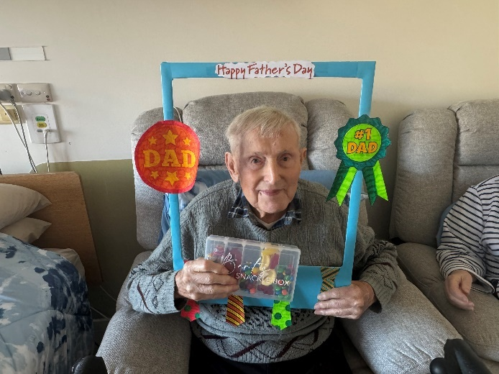
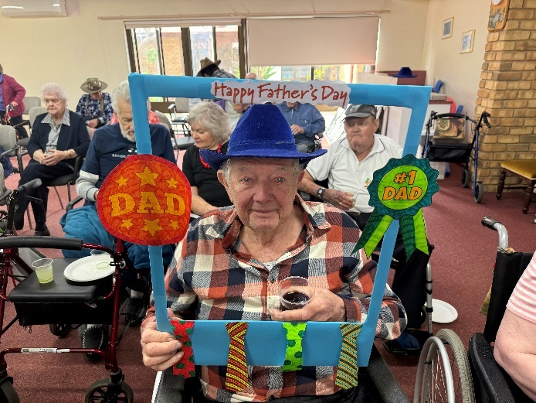

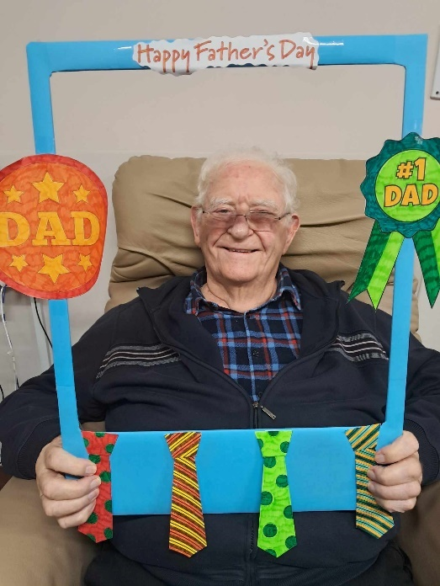
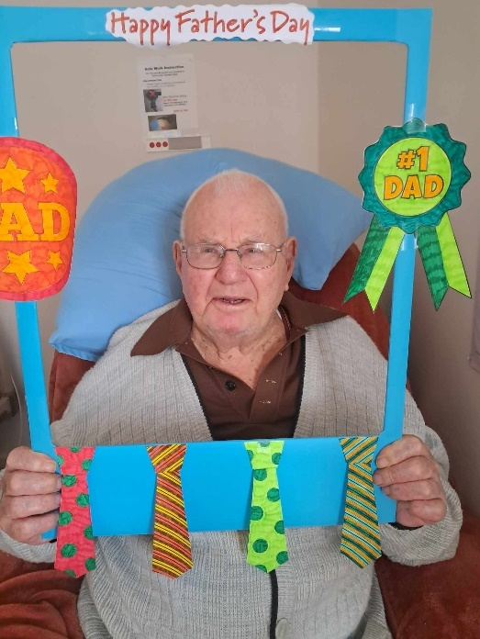

AFL Footy Colours Day:

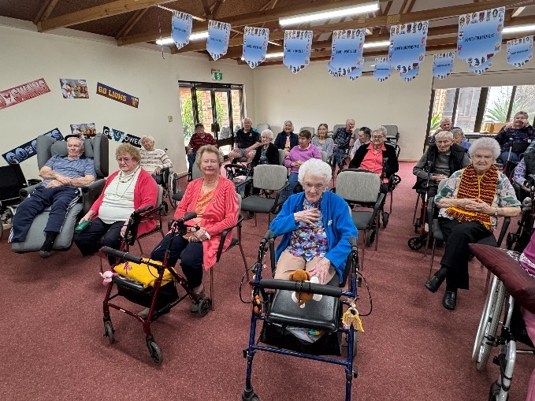
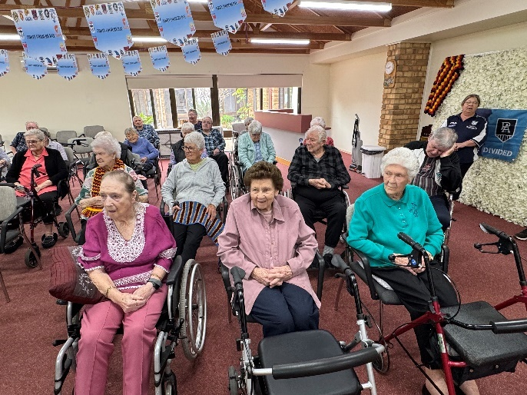
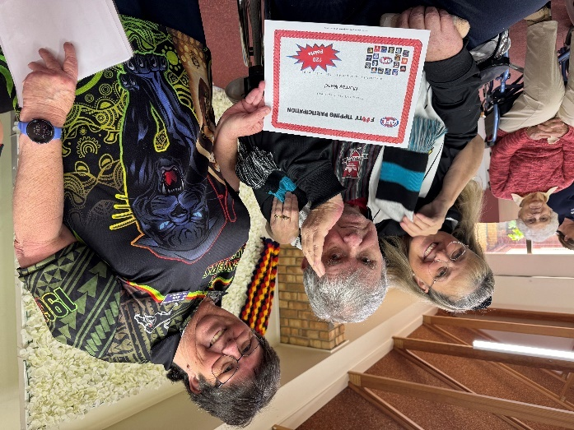
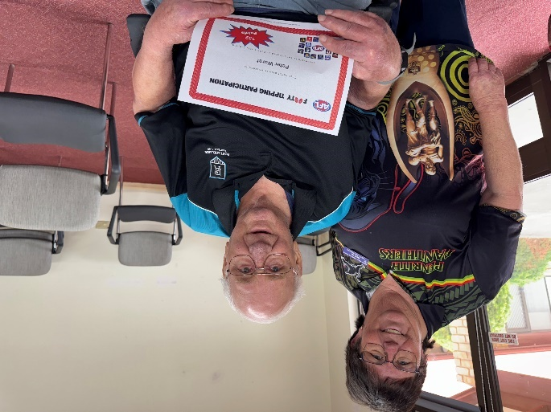

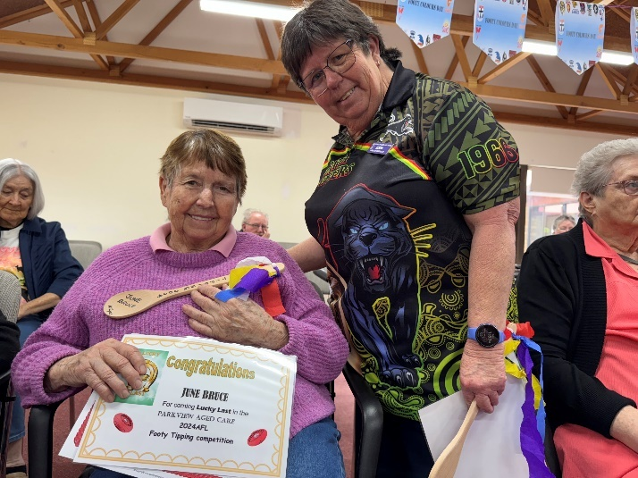
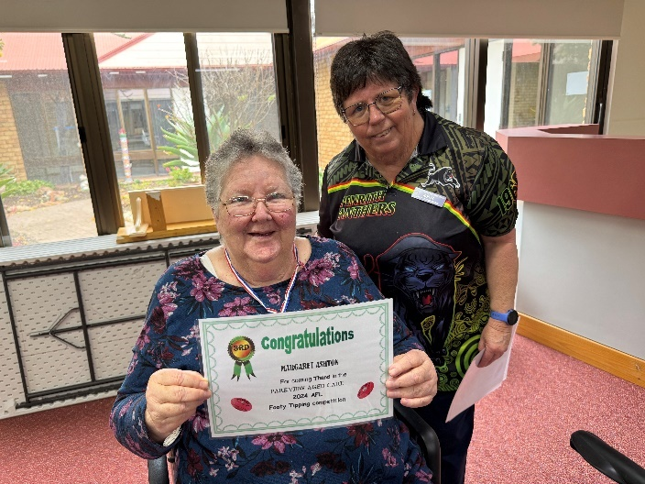

Sun of Africa:
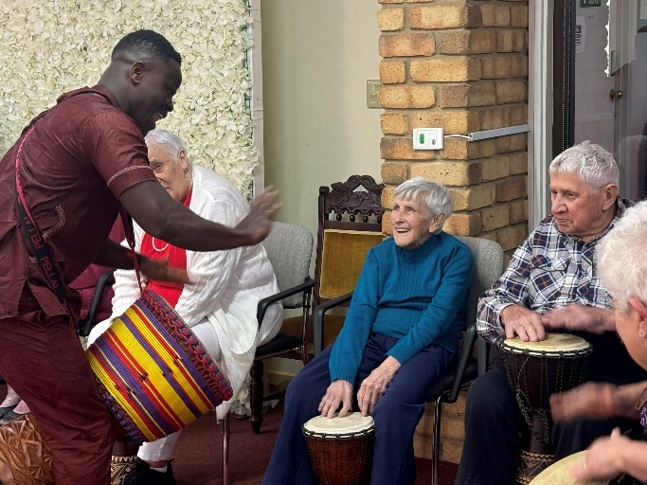
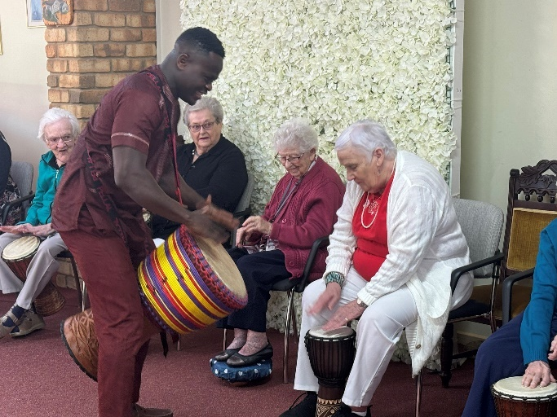

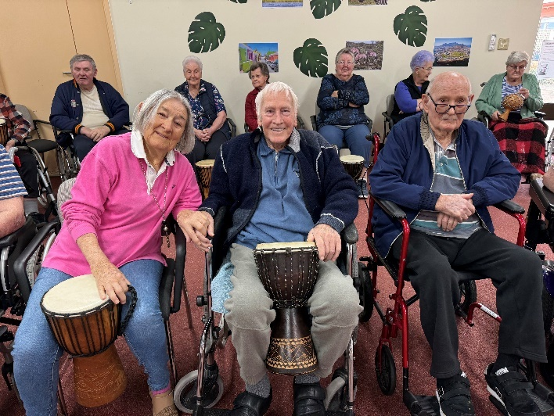
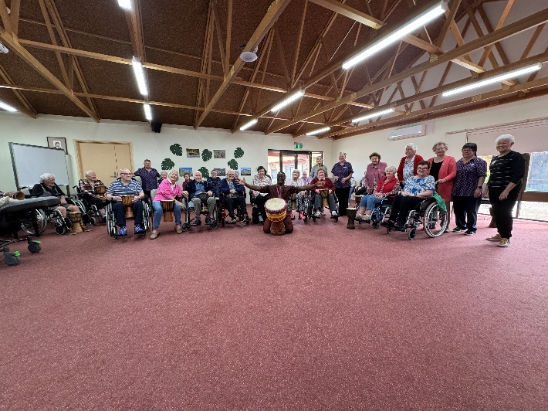

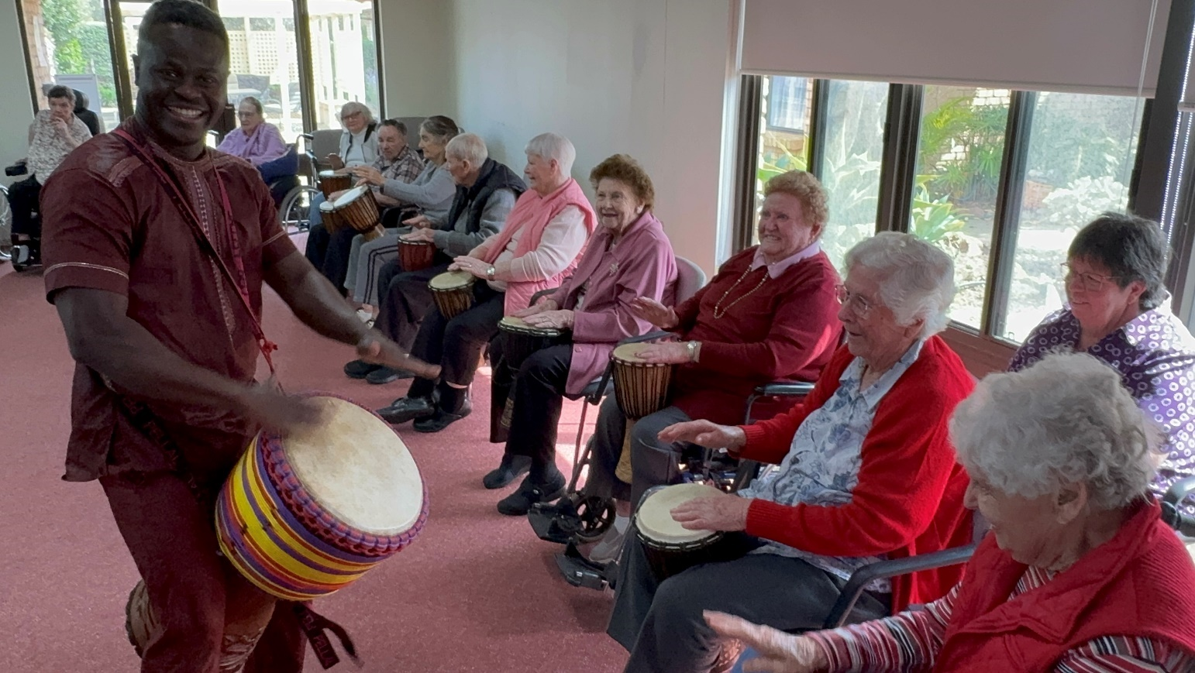

Halloween:
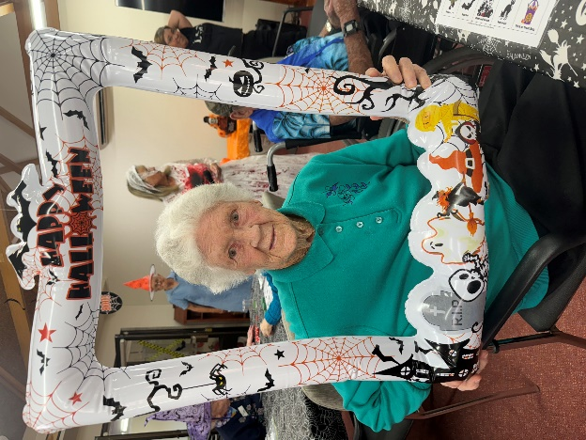
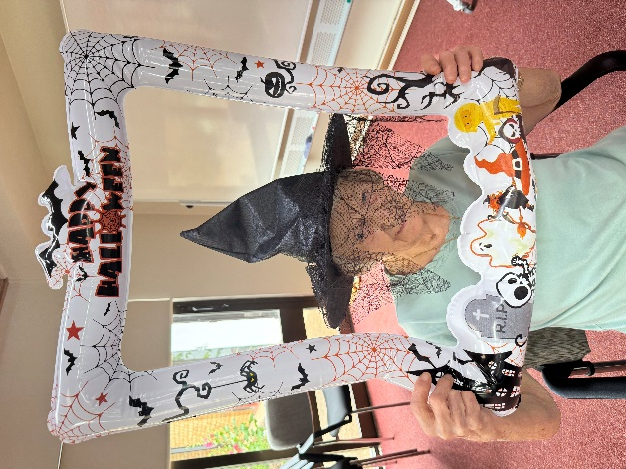
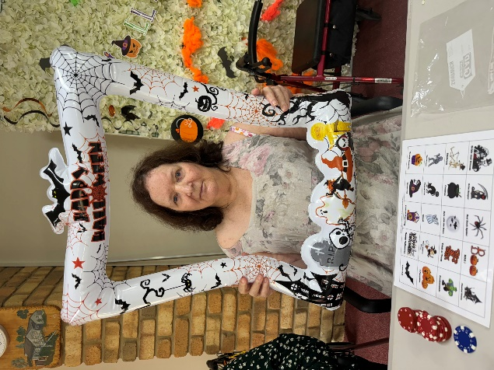

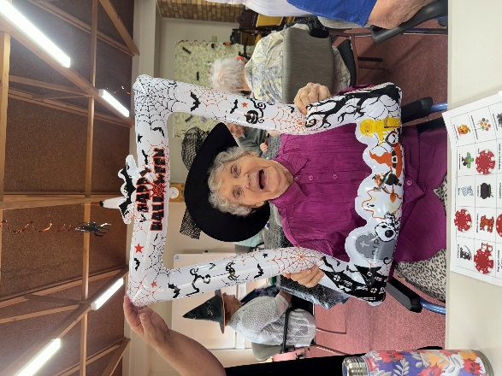
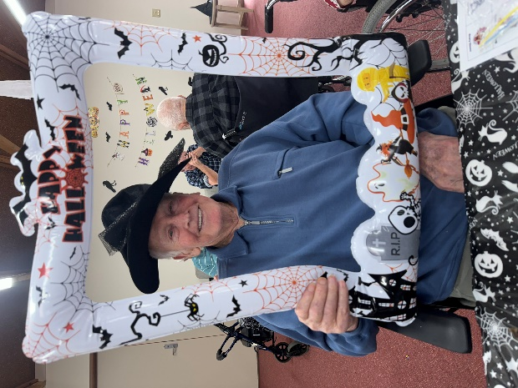
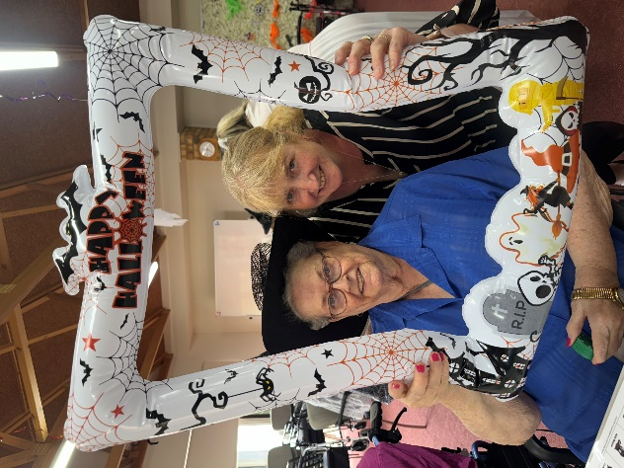

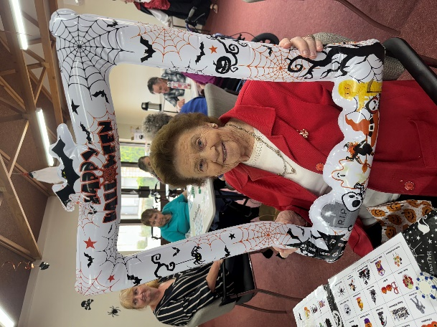
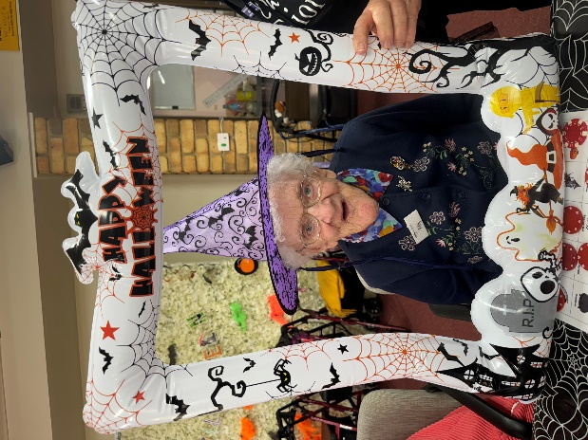
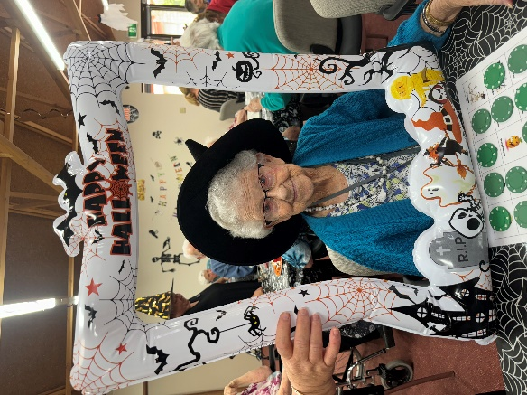

FUN SHIRT FRIDAYS

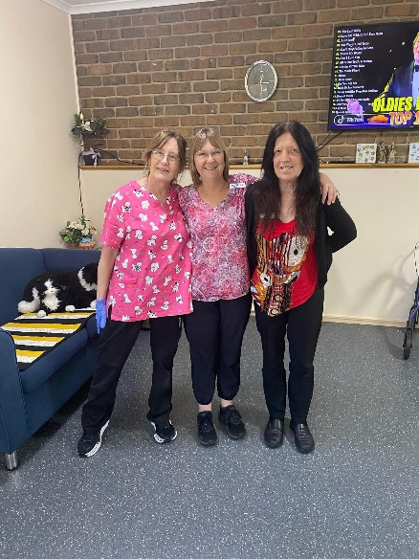

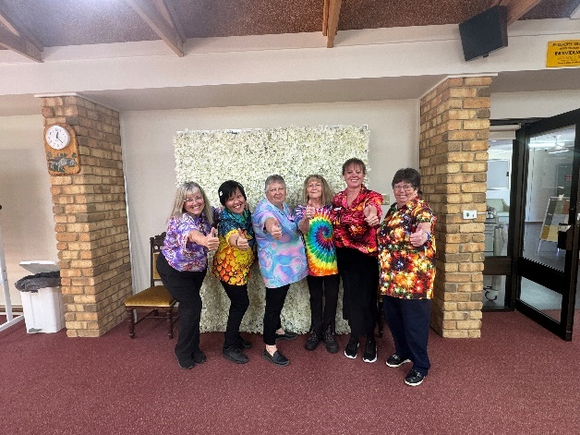


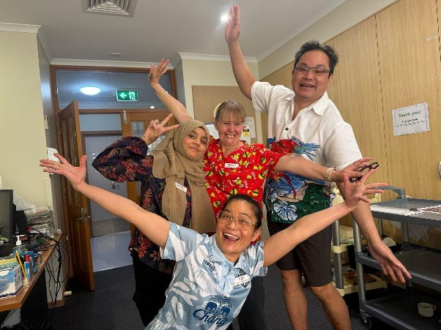

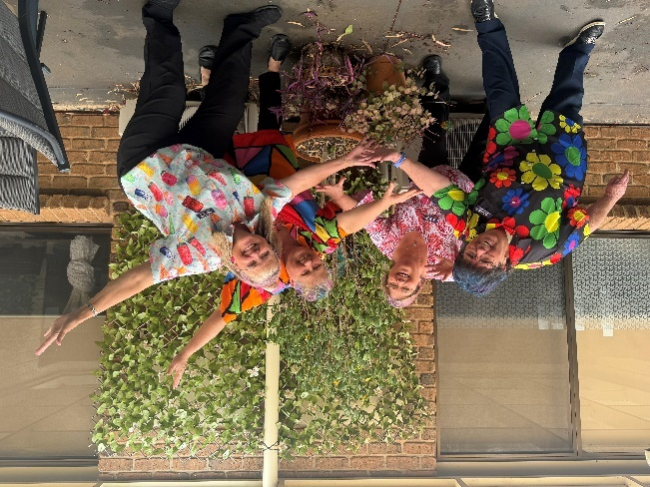
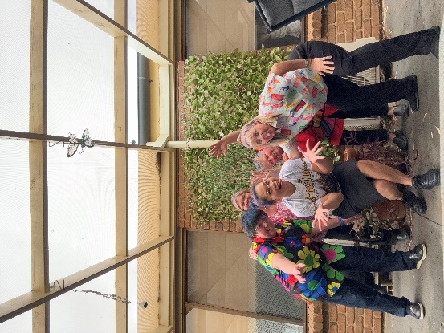



Welcome to our new residents…

- Jenny Chapman
- Shirley Hage
- Joy Gardiner
- Kath Kemp
- Kay Murdock


In Memoriam…..
Sadly we say goodbye to our much loved residents
- Shirley Richards
- Ruth Ringvall
- Betty Player
- Dean Bennie
To their family and friends may you find strength in the love of family and in the warm embrace of friends.
Caring for your loved one was a privilege.



CELEBRATING A BIRTHDAY IN NOVEMBER 2024
- Janet Berry 4th
- Ruth Hutchens 11th
- Janet Cheesman 13th 80th
- Ronda Leighton 15th
- Gaynor McVicar 18th 90th

CELEBRATING A BIRTHDAY IN DECEMBER 2024
- Robert Everett 1st
- Barbara Olive 5th
- Betty Thiele 6th
- Marion Goldsworthy 9th
- Trevor Mieglich 10th
- Kenneth McVicar 12th
- Margaret Chapman 13th 95th
- Joy Gardiner 16th 75th
- Viktor Kozman 16th
- Margaret Everett 24th
- Harold Rose 29th

How we doing?

FEEDBACK

Please tell us what you think of us, Compliments or Complaints.

SUGGESTION FOR IMPROVEMENT


How Can we do better, please let us know?

PARKVIEW NOTICE BOARD

We are looking for consumers or consumers representative to participate to form our Quality Care Advisory Body committee. Please notify Amanda, Senior Lifestyle Coordinator, if you would like to come on board.

Naming of areas,
We have had a review of the naming of the areas at our site. Traditionally we have the Low and High Care areas which don’t represent the care levels anymore as we are now “Ageing in Place”.
Following consultation and a survey of residents it has been decided that we have the following:
Low Care area will now be known as “Lower Level”.
High Care area will now be known as “Upper Level”.
This is because there is an incline between the Lower Level and the Upper Level. Many thanks to everyone who has been involved in this process. We are in the process of updating all of our collateral.

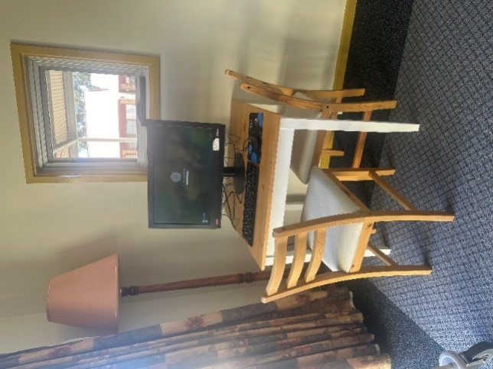
We would like to ceremoniously announce that there is now a computer available for residents to use! It has been installed in the corner of the “Butterfly Café” half way between Upper and Lower Levels. Feel free to use this whenever you like and if you would like a lesson on how to use it please let a member of our Lifestyle team know.

If you have ordered newspapers or any magazines etc. for your family member please inform any of the Lifestyle staff to ensure they receive the correct order. ALL newspapers etc. are the responsibility of the family to order or cancel either through the Advertiser and our local newsagency. Remember to specify to the newsagent if the paper is required in either PARKVIEW or NURSING HOME.

Fundraising – a number of items need replacement over the next year.
To help us fund these we are seeking donations from our community.
Did you know as a registered Charity all monetary donations over $2 are tax deductible?
Donations can be made via cheque, or cash deposited into our bank account
BSB 105 013 AC No 035893240 Please use “Donate” as reference and ring office to request your receipt.

Moonta Health & Aged Care Services Facebook Page

Come and join us, there are weekly video clips of the activities and important information to keep up with all aspects of our wonderful facility, at this stage we have 871 followers
Link: https://www.facebook.com/pages/category/Nonprofit-organization/Moonta-Health-Aged-Care-Service-111974350474584/
Or search ‘Moonta Health and Aged Care” into your Facebook search bar.



We are still looking for volunteers to assist the residents via Lifestyle department with games, bingo, cards, happy hour, newspaper reading, nail care, exercises, singalong and other activities. If you are interested, please do not hesitate to contact us as your help would be greatly appreciated. Our contact number is 8825 0000 and speak to Amanda Weger – Senior Lifestyle Coordinator. All volunteers will need to meet the infection control requirements.



Just a reminder to bring in any new and updated cards such as Medicare, Pensioner so we can update our records please!

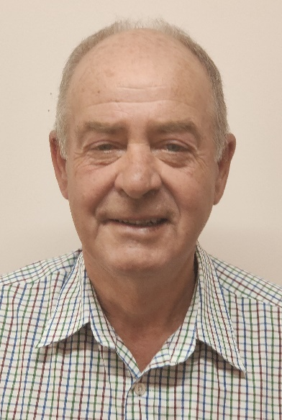
MHAACS PROFILES
Name: Peter Anderson MHAACS Board Member
I was born at Minlaton and raised on farming properties at Stansbury and later at Penola in the South East. I joined the Police Force in 1974 and spent the next 43years in a variety of areas, including CIB, Drug Squad, Major Crime, Policy Development, Forensic Services and other senior management roles. In that time I accumulated a Bachelor Degree in Social Science, a Master’s Degree in Public Policy & Administration and was awarded the Australian Policing Medal in the 2016 Queen’s Birthday honours list. I retired as a Detective Superintendent in charge of the Far North Local Service Area. I now live on my hobby-farm at East Moonta with my partner Allison. I have a 23 year old daughter who is a Solicitor living in Adelaide. I wanted to contribute to my community in retirement, so now I am the Chairperson of the Copper Coast Meals on Wheels, committee member at the Moonta RSL, CEO of the Yorke Peninsula Field Days and more recently a Board Member of the Parkview Aged Care Facility. My late father passed away while a resident of Parkview and the care and support he received as a resident was outstanding. I hope to do what I can to support the staff of Parkview in providing that same level of care and dignity to others.
Cheers,
Peter

MHAACS PROFILES

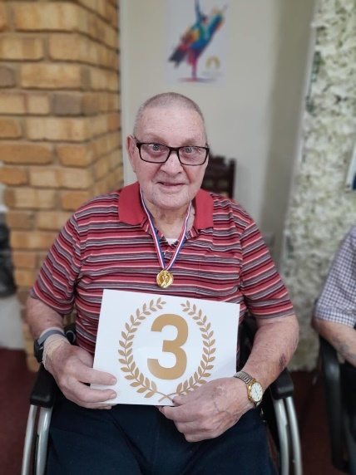
Name: James Talbot MHAACS Resident
Past Occupation: Truck Driver for EWS and Railway Driver
Places I visited: I loved going to Ballarat, Tasmania, New Zealand and the Flinders Ranges
Favourite Music: I love listening to Country Music
People important to me: My family and friends
Hobbies/Interests: Fishing and playing lawn bowls for Henley & Grange Bowling Club
Pets: I had a Kangaroo whom I hand raised called “Cotton”
Do you like living here: Yes, I do, I love it as it’s a lovable place, friendly people

MHAACS PROFILES

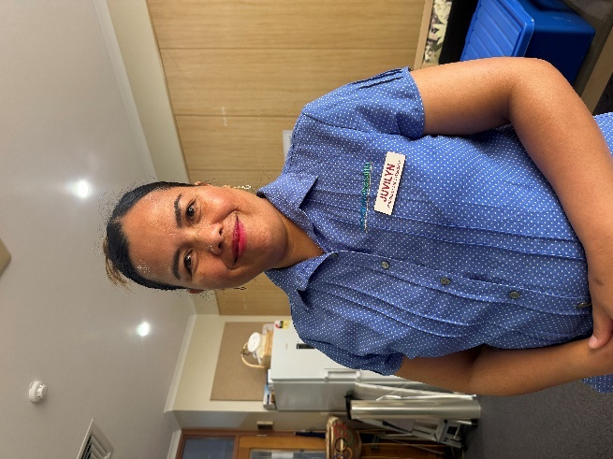
Name: Juvilyn Seaman MHAACS Staff Member
Place of Birth: Philippines
Spouse/partner: Martin Seaman
Children: One daughter named Martina
Occupation: Personal Care Attendant 2022 to current
Sport: Played volleyball when I was younger and now I like to watch AFL Football and the Cricket
Social: Love spending time with my family and singing with friends
Holiday: My favourite holiday was in New Zealand as my sister lives there!
What do you like most about your job: I love chatting to the residents and listening to their stories about their life and love caring for the them.



